**Samples Before Treatment**

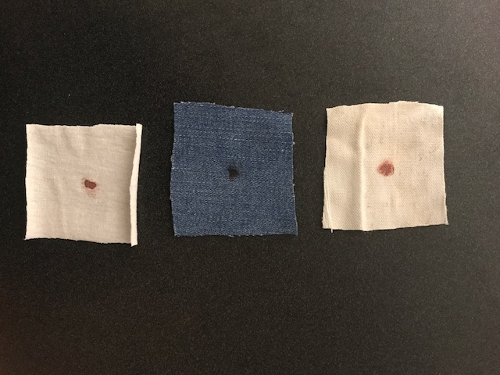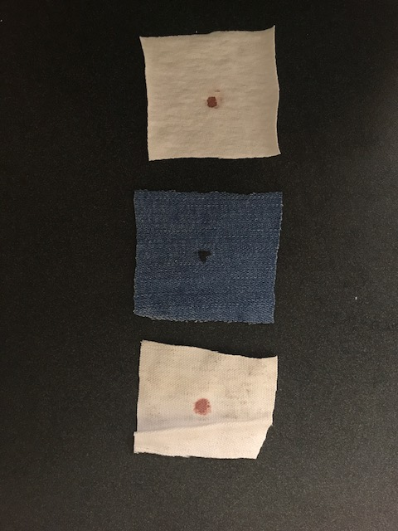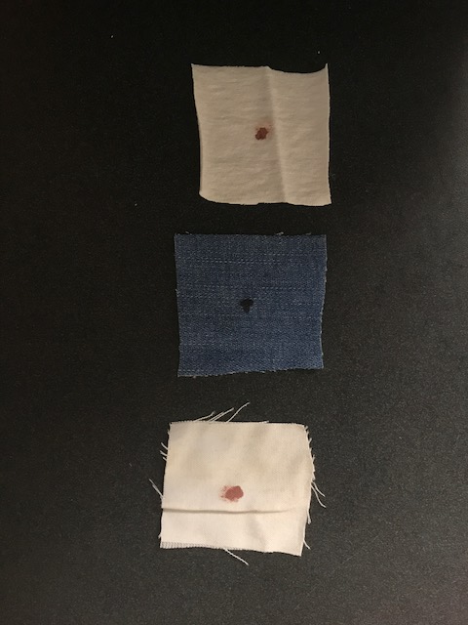

Cotton Denim Canvas

Cotton Denim Canvas

Cotton Denim Canvas

Control

Group 2

Group 1

**Samples After Treatment**

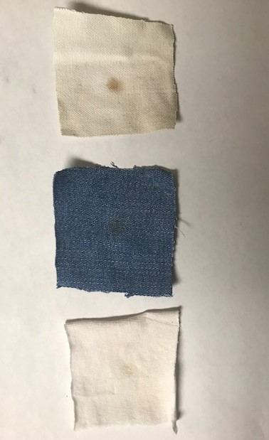 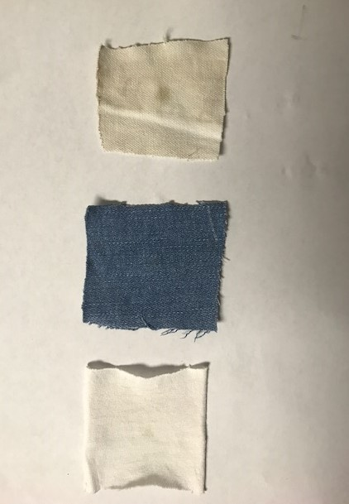

Group 1

Cotton Denim Canvas

Group 2

Cotton Denim Canvas

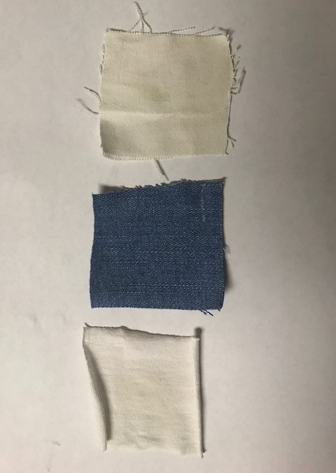

Control

Cotton Denim Canvas

**Paper Towels After Samples were Removed**

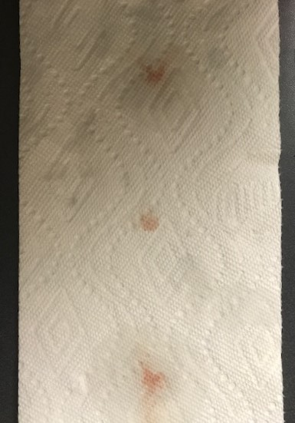 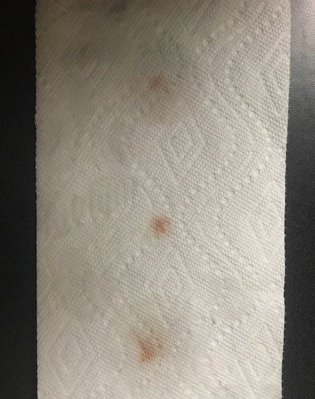

Group 2

Group 1

Cotton Denim Canvas

Cotton Denim Canvas

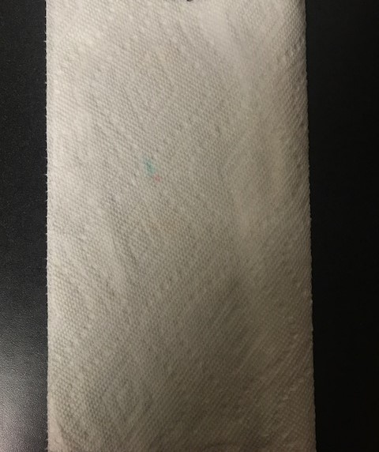

Control

Cotton Denim Canvas